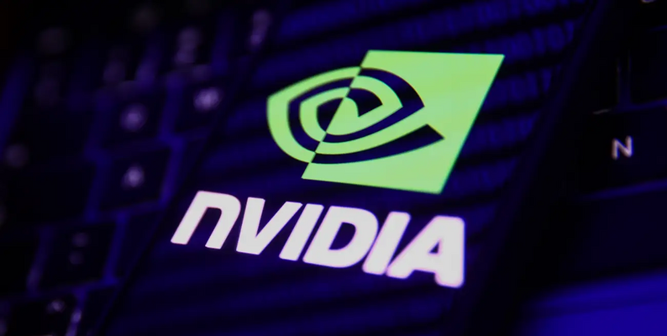

**COS30045 – Data Visualization**

**NVIDIA Stock Price Analysis and Visualization**

**Ta Nam Khanh**

**Ha Duc Trung Kien**

**Luong Anh Cuong**

1. **Introduction**

* Project Purpose: This project aims to analyze and visualize historical stock prices for NVIDIA Corporation, identifying trends and potential insights for investors.
* Objectives:
* Explore NVIDIA stock price trends over time.
* Develop interactive data visualizations to provide clear insights into stock movements.
* Utilize historical data for potential trend identification and market analysis.
* Target Audience: This project primarily serves financial analysts, stock market enthusiasts, and NVIDIA investors seeking historical trends and patterns.

1. **Project Planning**

* Timeline:
* Week 8: Gathering datasets, Project planning and setup (GitHub, Communication channels, Shared documents).
* Week 9: Research and understand the datasets. Start designing the visualisation
* Week 11 - 12: Development of data visualizations and working on report drafts.
* Week 13: Finish the Implementation of key features and continued testing.
* Week 14: Finalise the project, documentation, and preparing for submission
* Meeting schedule:
* Time: Every Friday, 3:00 PM - 4:00 PM  
  Day: Weekly on Fridays
* Roles & Responsibilities:
* Ta Nam Khanh: Conducts data analysis, prepares insights, and creates visualizations.
* Luong Anh Cuong: Handles backend development, data processing, and database integration.
* Ha Duc Trung Kien: Coordinates project tasks, manages documentation, and compiles the report.

1. **Methodology**

* Data Source: Historical NVIDIA stock price data was sourced from Kaggle
* Data Preprocessing:
* Loaded data and handled missing values by [e.g., removing or interpolating missing data points].
* Normalized date formats and standardized price fields (e.g., adjusted close, opening prices).
* Analysis Approach:
* Conducted preliminary analysis, calculating moving averages, volatility, and daily returns to understand stock trends.
* Prepared data for visualization by summarizing monthly and yearly price trends.
* Technologies Used:
* Frontend: HTML, CSS, and JavaScript for building the web interface.
* Backend: Nodejs for data processing and API development.
* Data Visualization: Libraries like Matplotlib or D3.js to create charts and interactive graphs.

1. **Design Choices**
   1. **Interface Design**

* Emphasized a clean layout for easy navigation through stock data visuals.
  1. **Color Scheme**
* Used a neutral color scheme to enhance readability and focus on data.
  1. **Data Visualization Types**
* We have introduced a candlestick chart to our suite of data visualizations, which provides a detailed view of NVIDIA's daily trading activity. Each candlestick represents a single day of trading with the following color scheme:
  + Green: The stock closed higher than it opened. These bars indicate buying pressure and are often considered bullish.
  + Red: The stock closed lower than it opened. These bars signify selling pressure and are generally viewed as bearish.
* The main body (the wider part) of each candlestick represents the opening and closing prices, while the lines (or wicks) extending above and below the body depict the highest and lowest traded prices of the day. This format allows analysts to quickly assess market sentiment and volatility for each day

1. **Technical Implementation**

* Using D3.js, we implemented the candlestick chart to enhance our analytical capabilities. The chart is constructed as follows:
* X-axis: Represents the sequence of trading days.
* Y-axis: Scaled linearly to represent the stock price range from the lowest to the highest trading prices.
* Rectangles and Lines: Each day's trading range is depicted by rectangles and lines; their placement and height are determined by daily high, low, open, and close values.

  var svg = d3.select("#chart")

    .append("svg")

  .attr("width", w)

.attr("height", h);

var rects = svg.selectAll("rect")

.data(dataset)

.enter()

.append("rect")

.attr("x", (d, i) => xScale(i))

.attr("y", d => d.close > d.open ? yScale(d.close) : yScale(d.open))

.attr("width", xScale.bandwidth())

.attr("height", d => Math.abs(yScale(d.open) - yScale(d.close)))

.attr("fill", (d) => d.open < d.close ? "green" : "red");

1. **Challenges and Solutions**

* Data Gaps: Encountered missing values in certain dates. Solution: Applied linear interpolation to fill missing points.
* High Variability in Stock Data: Stock prices showed high volatility, complicating trend analysis. Solution: Used moving averages to smooth data and highlight trends.
* Integration Challenges: Issues with rendering large datasets in visualization libraries. Solution: Limited displayed data range and optimized loading for improved performance.
* Rendering Large Datasets: We encountered challenges with rendering large datasets, which caused performance issues in our visualizations. To address this, we optimized the data loading process and adjusted the D3.js rendering logic to only display a subset of data at any given time, significantly improving performance and user interaction.

1. **Results and Analysis**

* Summary of Findings:
* Identified periods of significant growth and decline in NVIDIA's stock price, correlating with major market events.
* Observed consistent trends that may indicate seasonal or annual cycles in the stock performance.
* Data Insights:
* The analysis highlighted key periods of NVIDIA's stock price volatility, useful for assessing investment timing.
* Visualization of moving averages provided a smoother view of stock trends, useful for longer-term analysis.
* User Feedback: Initial feedback from users indicated that the visualizations were intuitive and valuable for understanding NVIDIA's stock performance.
* The candlestick chart:
* Periods of Significant Growth and Decline: We identified distinct periods where NVIDIA's stock showed rapid growth or sudden declines, correlating with major product releases or financial reports.
* Market Sentiment Analysis: The visualization helped in analyzing investor sentiment, providing a clear picture of the market dynamics affecting NVIDIA's stock price.

1. **Reflections and Future Work**

* Lessons Learned:
* Data cleaning and preprocessing are essential for reliable analysis.
* Visualization design significantly impacts user understanding, especially with financial data.
* Areas for Improvement:
* Further improve data loading speeds for larger datasets.
* Explore additional financial indicators (e.g., RSI, MACD) to enhance stock trend analysis.
* Future Work:
* Expand analysis to include comparisons with industry peers.
* Integrate real-time stock data for a live price tracking feature.